Biometric Identification using

Forehead Wrinkles

## 1 Data Collection

The data was gathered from different ages and genders to have a varied data set. We have used an Android Application called FaceWrinkle App to get the data from different persons on different sessions. We have gathered 5 images from far and 5 images from close from every person in a session. Time gap between the 2 sessions was 24hr. The data set contains 600 images i.e 20 images from 30 persons. We have named each image with respect to the session no, person no, picture no, and far or close image.

## 2 Experimental Findings and Results

### 2.1 nxn matching using popular feature extractor

Image matching is an important concept in object recognition. It is best to find the features that are descriptive and invariant in order to categorize the images correctly. These features are derived from the images using Scale Invariant Feature Transformation i.e SIFT. SIFT is a computer vision detection algorithm. SIFT helps to locate the local features in an image, also known as the keypoints. We can use the keypoints generated by SIFT as features for the image during training. The function detectAndCompute provided by SIFT extracts the keypoints from an image. We store this data in a dictionary for later uses. Then we compare the keypoints of every image with other images keypoints using match function provided by opencv library. We deduce a score for every pair and store it in text file for future purposes. In this way we match two images using SIFT feature extractor.

### 2.2 Getting the Scores

To get the scores we have used a function match() from the BFmatcher module also known as brute force match module. We use a function knnMatch to get k best matches. We use k=2 so that we can apply ratio test explained by D.Lowe. We calculated the total good matches. Then to obtain score we divide this total no of good by no of keypoints(i.e max of keypoints of both images). We calculate the score between every pair(except the image with itself) and store the scores result in a text file.

### 2.3 Genuine and Imposter Histogram

Two seperate lists are used for matches of the same person and matches of different person. Genuine list contains scores of same person matchings and Imposter list contains scores of different person matchings. To show the difference between Genuine and Imposter lists we have plotted a histogram between them. As it would be difficult to point out each score in a histogram of very small length, we have plotted the histogram by taking intervals in scores and plotted a probability graph corresponding to how many scores are present in that interval. Two graphs are plotted by taking 25 intervals or bins between scores 0 and 1 for one graph and taking 25 intervals between scores 0 and 0.1 for another graph.

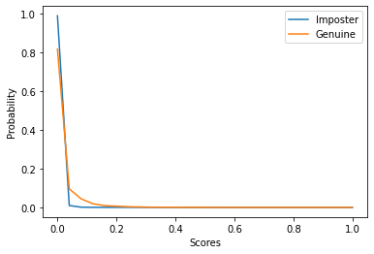

Taking 25 bins between 0 and 1 scores

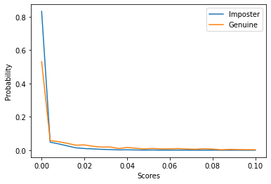

Taking 25 bins between 0 and 0.1 scores

### 2.4 Plotting the ROC curve

An ROC curve is obtained by plotting False Rejection Rate (FRR) vs False Acceptance Rate (FAR), by varying the decision threshold.

FAR refers to the likelihood of the biometric system to incorrectly accept an unauthorized user as an authorized one i.e. the rate of false acceptance over the number of imposter attempts. It is defined as:

*Number of incorrect matches recognized*

*FAR* =

*Total number of matches*

FRR on the other hand, is the likelihood of the biometric system to incorrectly reject an authorized user by considering him to be an unauthorized user, i.e the rate of false rejection over the number of genuine attempts by the user. It is defined as:

*Number of correct matches not recognized*

*FRR* =

*Total number of matches*

The decision threshold is the threshold to decide if the two images are a match or not depending on the score between them. If the score is less than the threshold then it is not a match, if it is greater then it is a match. If we find a match we check whether it is truly a match or not by comparing the names of both images. Matched images should have same person number in their name. So we calculate the FRR and FAR for different threshold values between 0 and 1 and store both of them in two seperate lists. Then we plot the graph between these lists and we get the ROC curve. ROC courve for this data set is shown in below figure.

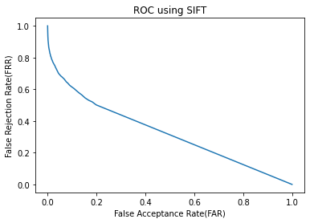

ROC curve for the given data set

### 2.5 EER and Corresponding Threshold

The FAR and FRR value always go opposite. If the decision threshold is increase then

FAR decreases and FRR increases, if decision threshold decreases FAR increases and FRR decreases. To get an equilibrium point between these two values we take the point where these both values gets equal. So EER(Equal Error Rate) is the point at which the False Acceptance Rate (FAR) and False Rejection Rate (FRR) are equal. It gives a threshold to evaluate the recognition performance of a system. Also, a system with lower EER is considered better. Since the thresholds we take have a precision of 0.001, we can’t get the threshold at the exact EER point. So we take the absolute difference between FAR and FRR and see where it is minimum or almost equal to zero. Then that threshold value will become our Corresponding threshold for EER point.

We also found the accuracy for this model.

Accuracy is the maximum value of (100 - 50*( FAR + FRR )) across all thresholds.

The Accuracy obtained by this SIFT model is 65.053%

### 2.6 Correct Recognition Rate (CRR)

It is defined as the number of actual matches that are obtained at rank one recognition.

*Number of correct matches recognized*

*CRR* =

*Total number of matches*

Number of correctly recognized cases can be found using the dictionary data structure.I found a maximum score for a given image when the image is the first one in the text file and the second image is not the exact same image. Finally, the number of active matches is found and divided by the total number of pictures. For this model the CRR value is 0.7412844036697248

## 3 Using different feature extractors

|  |  |  |  |  |  |  |
| --- | --- | --- | --- | --- | --- | --- |
| Feature Extractor | Histogram (for 25 bins ) | ROC Curve | EER | EER Threshold | Accuracy | CRR |
| SIFT |  |  | 0.3505 | 0.001 | 65.0536% | 0.741284 |
| ORB |  |  | 0.4088 | 0.002 | 59.1198% | 0.531914 |
| SURF |  |  | 0.33907 | 0.006 | 67.9265% | 0.807958 |
| BRIEF |  |  | 0.40223 | 0.066 | 59.7769% | 0.426966 |

All the required calculations and plots were made and plotted for ORB, SURF and BRIEF feature extractors. The above table gives a clear comparision between these different features.

## 4 Observations and Conclusions

From the above table we can see that SURF is the best feature extractor for this data set. We can see that the Accuracy and CRR values are highest for this feature extractor. Also a system with low EER value is considered best. EER value is also low for this extractor.

Another observation is that the probability of the scores to be in between 0 to 0.1 is higher than other intervals. This says that our feature extractors are not that great. If they are great the scores would have been more in the range of 0.5-1. But we can use these extractors and set a perfect threshold for better results.